

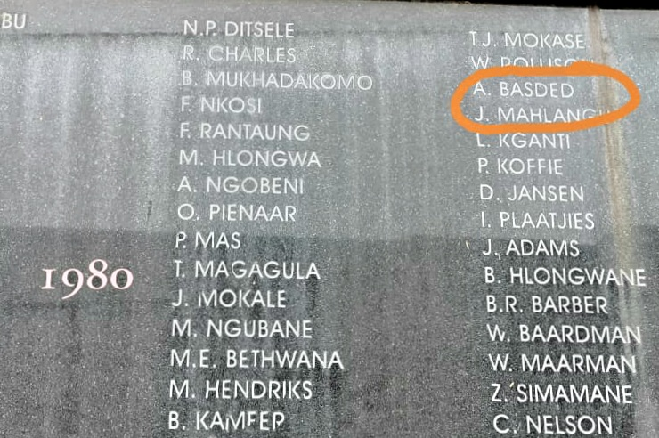
Amichand Basdeo’sname is displayed on the plaque at the gallows in Pretoria

